

**<<ONLINE LEARNING>>**

**Final Release Document**

– Hanoi, Jul 2022 –

**Table of Contents**

I. Deliverable Package 3

II. Installation Guides 3

III. User Manual 3

1. Overview 3

2. <<Workflow Name 1>> 3

2. <<Workflow Name 2>> 3

# I. Deliverable Package

*[The section will list all source programs, scripts, documents with version number in this release. You can see the example following table for reference, can customize or delete if not using belong to each project characteristics]*

| **No.** | **File** | **Notes** |
| --- | --- | --- |
| 1 | [OnlineLearning_DB_final.sql](https://drive.google.com/drive/u/0/folders/1YMv_cVWxGIBjiyn7qIeOMv9ZSLvfiVOA) | Database, including both table structures and table data |
| 2 | [Template2_SRS Document.docx](https://docs.google.com/document/d/1v5td4U0EsaJ3piLhOymdewmD9t2gALcs/edit?rtpof=true) | Final SRS (Requirement) Document |
| 3 | [Template3_SDS Document.docx](https://docs.google.com/document/d/1sfDGEE4ca6P4uvGp61RUYFS6-IXTN3wl/edit?rtpof=true) | Final SDS (Design) Document |
| 4 | [Product Backlog](https://docs.google.com/spreadsheets/d/1eevcyg6d09NbakHwwmd7FqZUf-iHU8nxTef4_J0Pf7U/edit#gid=0) | Final status for the application functions, which include:  - Function name, feature, roles, function description (changes compared to the original requirements are highlighted)  - In Charge, Planned iteration & Actual iteration  - Final status & note on the update you made  - The links to the SRS & SDS are tracked |
| 5 | [Template4_Issues Report.xlsx](https://docs.google.com/spreadsheets/d/17qloW2X86S8O95wweqsZjGG-mvEwNvjk/edit#gid=486580136) | Final issues tracking list of the whole project |

*XYZ include the student’s group code & project code (i.e: G1-HRM, for the group G1 who develop the Human Resource Management system).*

Other related deliverables:

* Tagged source codes: <<git lab tag link>>
* Demonstration video: <<YouTube link>>

# II. Installation Guides

***- Installation environment:***

*+ Installation JDK :*

*+ Installation APACHE NETBEAN 13:* [*link download*](https://netbeans.apache.org/download/nb13/nb13.html)

*+ Installation*

***- Run the project:***

*+ Connect database in MS SQL*

*+ Fill in blank:*

*● Connection Name: SWP391_ONLINELEARNING*

*● Hostname: localhost*

*● Port: 9999*

*● Username: sa*

*● Password (Store in Vault):12345*

*-> Press OK*

# III. User Manual

[In this part, you provide overall descriptions of the application, the briefs of the application’s workflows and the details guide of each workflow where the end user can use

## 1. Overview

*This is the workflow for Online Learning System with an image and their corresponding detail description in each screen/operation. And it also includes authorized roles in the system and pre/post-condition with exception ( if have ).*

## 2. Workflow

## 2.1 <Login>

- Actor: User

- Pre-condition: User can can access to the internet

User have valid account to access the system

- Post-condition: authorized users can have the right to access the system with their corresponding default screen.

- Normal flow:

+ At the Home Page screen, click the Login button at the corner screen.

+ The system will navigate to the Login screen.

+ Users enter their information to login into the system.

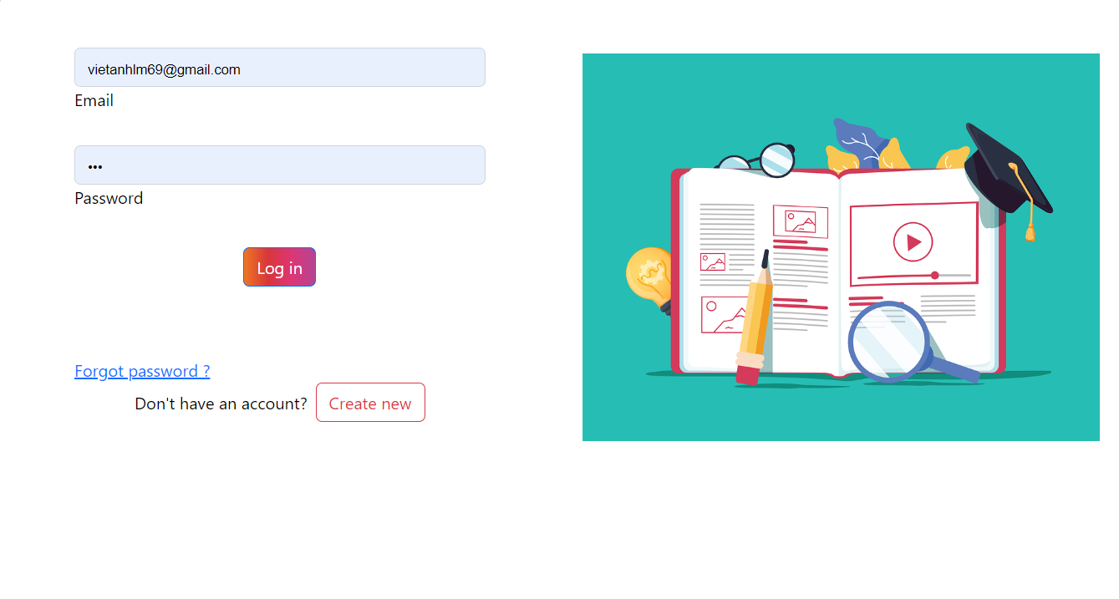

+ The system redirects to the homepage screen when successfully logged in.



## 2.1 <Register>

- Actor: User

- Pre-condition: User can can access to the internet

- Post-condition: Users register successfully to the system and have a valid account with role student.

- Normal flow:

+ At the Home Page screen, click the **Register** button at the top right corner.

+ The system will navigate to the Register screen.

+ Users enter their information to register into the system.

## 2.2 <Manage Account>

- Actor: administrator

- Pre-condition:

+ User can can access to the internet

+ User has signed in to the system with role “admin”



- Post-condition:

+ Admin can view, update and delete data of any users

- Normal flow:

+ At the Admin Home Page screen, click to avatar and choose “Manage Account” to show list user

+ Admin can modify any account in the account list including change role, delete.

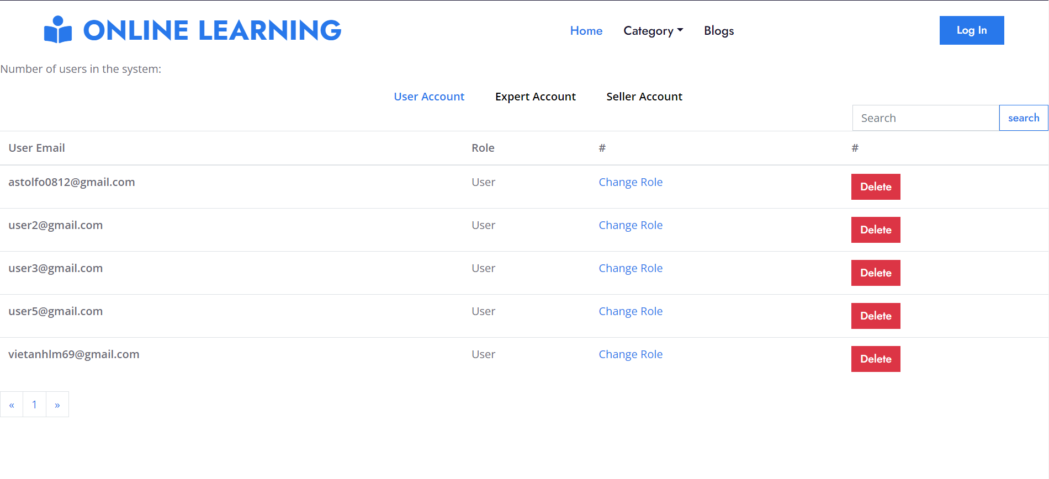

* Click “ Change Role” in the rightmost screen to change role this account.
* Click “Delete” in the rightmost to delete the account.

## 2.3 <Manage Course>

- Actor: Expert

- Pre-condition:

+ User can can access to the internet

+ User has signed in to the system with role “expert”



- Post-condition:

+ Expert can add, update and delete data of any course

- Normal flow:

+ At the ExpertHome Page screen, click to avatar and choose ”Manage Course” to enter the management page

+ Expert can add a new course by entering attributes named in the table, then click “ADD ONE” button to save.

+ Expert can update an exist course by modifying attributes named in the table, then click “UPDATE ONE” button to save.

+ Expert can delete a course by entering only ID of the course, then click “DELETE ONE” button to save.

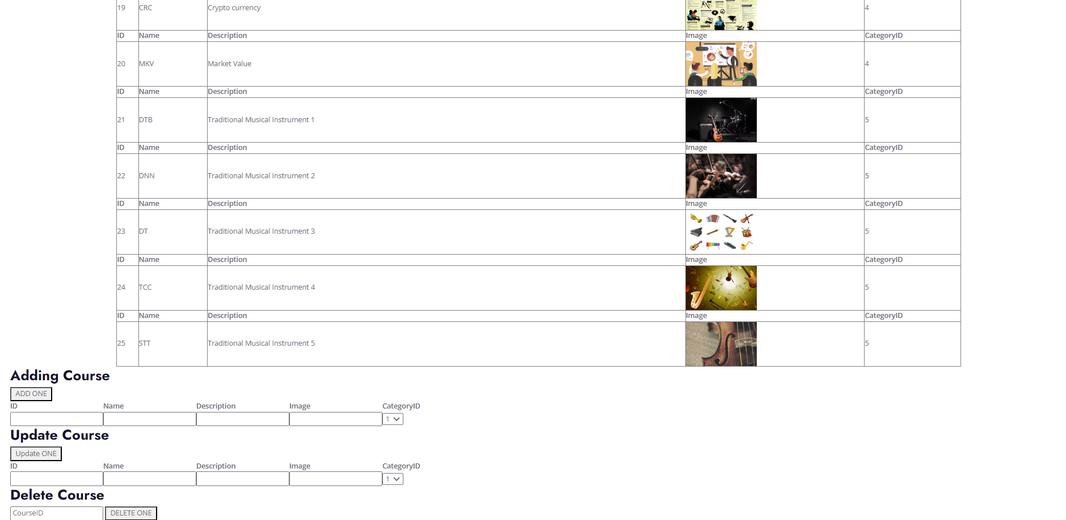

## 2.4 <Manage Lesson>

- Actor: Expert

- Pre-condition:

+ User can can access to the internet

+ User has signed in to the system with role “expert”



- Post-condition:

+ Expert can view, update and delete data of any Lesson

- Normal flow:

+ At the Expert Home Page screen, click to avatar and choose “Manage Lesson” to show list lesson

+ Expert can modify any lesson in the account list including change information

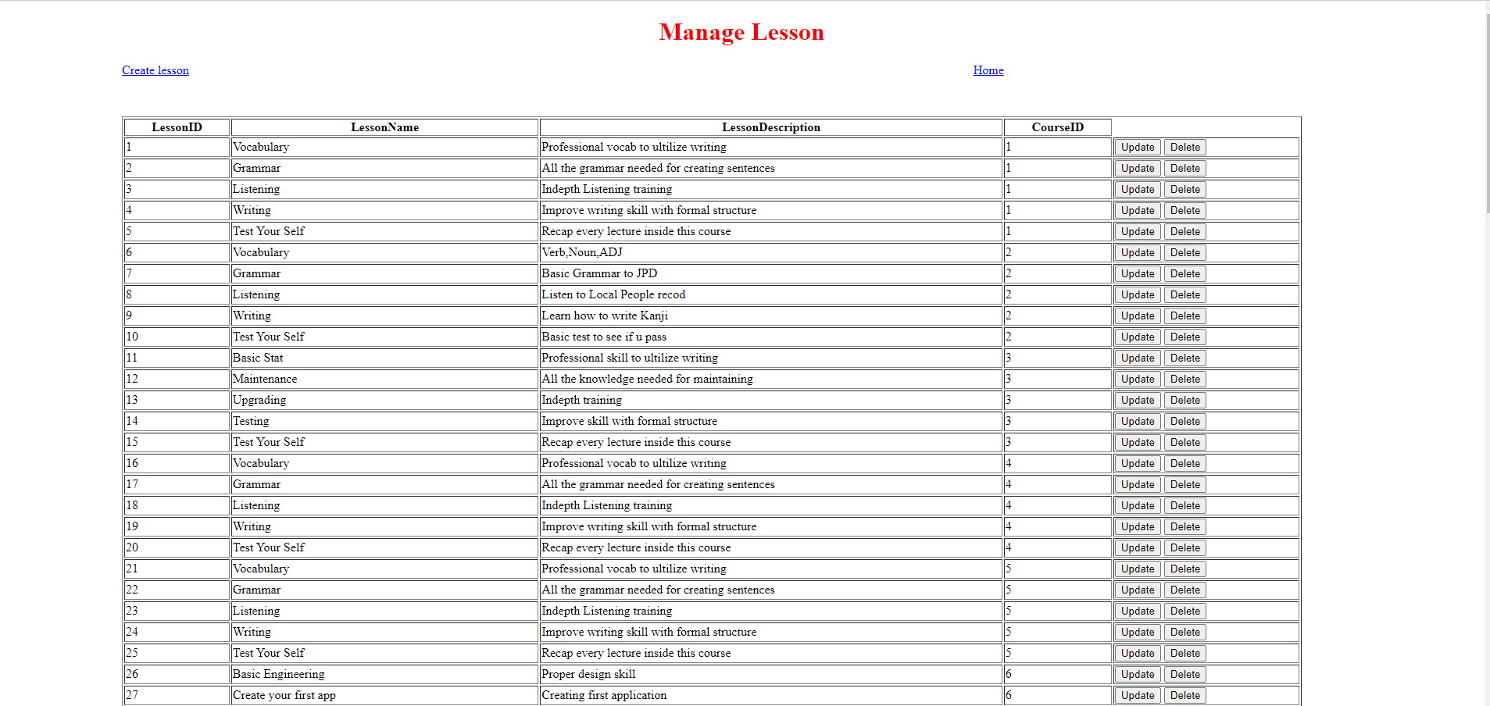

* Click “ Create Lesson” in the leftmost screen to create new lesson
* Click “Update ” in the rightmost to modify the information
* Click “Delete” in the rightmost to delete the lesson.

## 2.5 <Manage Flashcard>

- Actor: Expert

- Pre-condition:

+ User can can access to the internet

+ User has signed in to the system with role “expert”



- Post-condition:

+ Expert can view, update and delete data of any FlashCard

- Normal flow:

+ At the Expert Home Page screen, click to avatar and choose “Manage FlashCard” to show list FlashCard

+ Expert can modify any FlashCard in the account list including change information

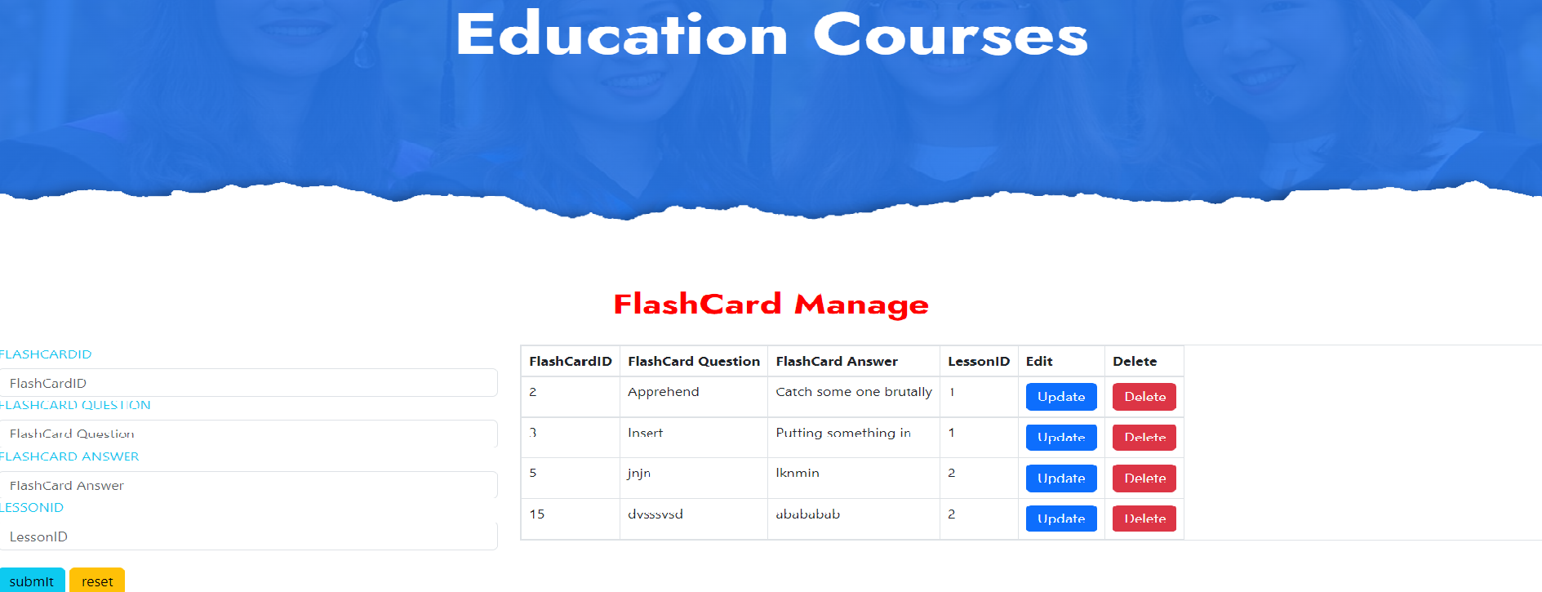

* Click “ submit” in the leftmost screen to create new flashcard
* Click “reset” in the leftmost screen to delete information textbox
* Click “Update ” in the rightmost to modify the information of flashcard
* Click “Delete” in the rightmost to delete the flashcard.

## 2.6 <Manage Blog>

- Actor: Seller

- Pre-condition:

+ User can can access to the internet

+ User has signed in to the system with role “seller”



- Post-condition:

+ Seller can add, update, delete and view data of any blogs

- Normal flow:

+ At the seller Home Page screen, click to avatar and choose manage blog to show list blog

+ Seller can modify any blog in the blog list including change information, delete

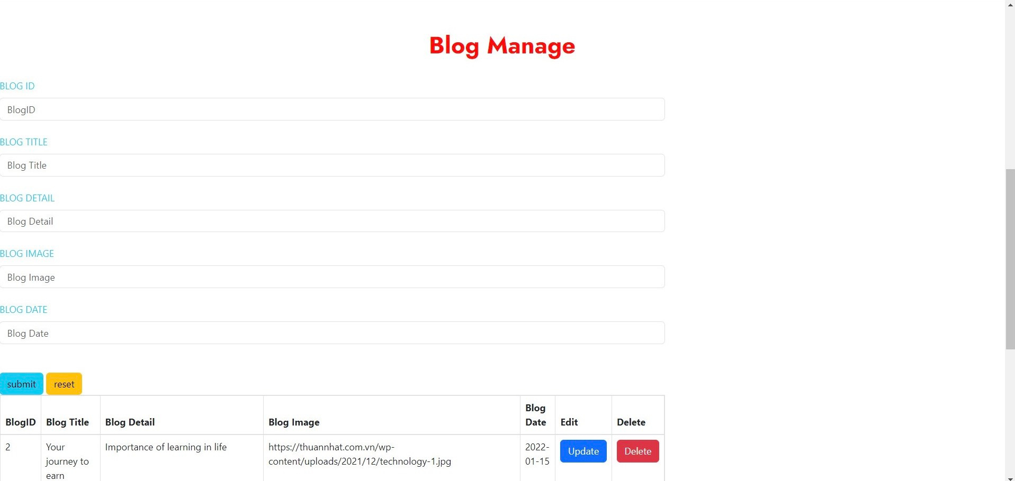

* Click “ submit” in the leftmost screen to create new blog
* Click “reset” in the leftmost screen to delete information textbox
* Click “Update ” in the rightmost to modify the information of blog
* Click “Delete” in the rightmost to delete the blog.